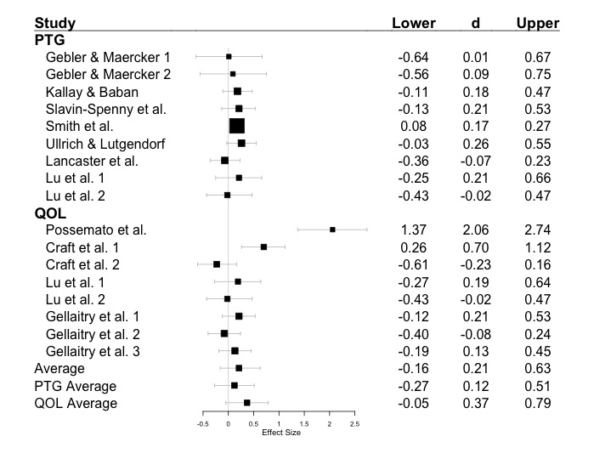

*Figure 1.* Forest plot with average Cohen’s *d* effect sizes and noncentral confidence intervals. Box size is determined by the weight of the experiment, wherein larger sample sizes are given more weight. The overall unweighted average, PTG, and QOL average are provided.